Research Article  Volume-1 | Issue-1 | Jan-Jun-2025 | JOURNAL OF  Computer Science and System Software  Double Blind Peer Reviewed Journal  DOI: https://doi.org/10.48001/JoCSSS

SkillSync Campus: A Unified Multi-Module Platform for Student
Networking, Placement Preparation, and Skill Development
Rishabh Rawat¹, Sumiran Sharma¹, Abhishek Karan¹, Ashish Patel¹
¹Department of Computer Science and Engineering, Dronacharya Group of Institutions,
Greater Noida, Uttar Pradesh, India
*Corresponding Author’s Email: [author@email.com]
ARTICLE HISTORY:  Received: 10th Jan, 2025  Revised: 5th Feb, 2025  Accepted: 15th Feb, 2025  Published: 1st Mar, 2025  KEYWORDS:  Alumni networking, Campus platform, Coding practice, Placement preparation, Skill development, Student collaboration | ABSTRACT: During our time as engineering students, we noticed a common problem — there is no single place where students can connect with alumni, prepare for placements, practice coding, and get answers to their doubts all at once. Everyone ends up juggling LinkedIn, LeetCode, WhatsApp groups, and GitHub separately, which gets quite messy. That is what pushed us to build SkillSync Campus. It is a web and mobile platform that brings together alumni-student networking, placement content, a coding compiler, a discussion forum, a project showcase, and an admin panel, all under one login. We built it using Node.js, Express.js, React, Flutter, PostgreSQL, MongoDB, Socket.io, and the Judge0 API for running code. This paper walks through how we designed and developed the platform, what problems we faced, and why we made certain technical choices. We believe SkillSync Campus can genuinely change how students experience college — especially when it comes to placements and skill building.

1. INTRODUCTION
If you look at how most college students manage their academic and professional lives today, it is basically a mess of open browser tabs — LinkedIn for networking, LeetCode for coding prep, GitHub to host projects, WhatsApp groups for doubt-solving, and maybe a few college portals that barely work. None of these tools talk to each other, and students end up wasting a lot of time just trying to figure out where to go for what. This problem is something we personally experienced during our own college journey, and it made us think — why hasn’t anyone built something that actually fits how a student’s day-to-day needs look?
SkillSync Campus started as that idea. The goal was simple: bring everything a college student genuinely needs into one place. Alumni connections, placement study material, coding practice with a live compiler, a proper Q&A forum, and a space to show off projects — all accessible from a single account. Faculty and admins also get their own space to manage content and moderate discussions. We built this for students of Dronacharya Group of Institutions initially, but the design is general enough that any college could use it (Kumar & Sharma, 2022).
The rest of this paper covers how we actually built it. Section 2 talks about the tech stack we chose and why. Section 3 explains our development approach step by step. Section 4 looks at what similar platforms exist and how SkillSync differs. Section 5 discusses what we observed and learnt, Section 6 covers our key contributions, and Section 7 wraps things up.
2. TECHNOLOGICAL LANDSCAPE
Choosing the right tech stack took us a while honestly. We wanted something that was widely used, well-documented, and wouldn’t require us to start from scratch every time we added a new feature. We settled on Node.js for the backend because it handles multiple requests without slowing down, which matters a lot when students are simultaneously browsing alumni profiles, submitting code, and chatting in forums. For data storage, we used both PostgreSQL and MongoDB — PostgreSQL for things like user profiles and placement content where the data is structured and relational, and MongoDB for forum posts and chat logs where the structure varies.
For the frontend, we went with React for the web side and Flutter for mobile. Both share a component-based approach, so once we had our UI components designed, reusing them across screens was pretty straightforward. Flutter was a bit new to some of us but we found it manageable. The code stays readable and making changes doesn’t usually break other parts, which saved us a lot of debugging time during development (Prinster et al., 2024).
Real-time features like chat and notifications were handled using Socket.io. We considered polling at first, but WebSockets through Socket.io felt much more natural for a chat interface — messages appear instantly without the user having to refresh anything. REST APIs handle everything else: fetching data, posting content, user authentication. It’s a clean separation that made testing individual features much easier.
The coding practice module was probably the most interesting part technically. We integrated Judge0, which is an open-source code execution engine that supports over 60 programming languages. Students write code in the browser, hit submit, and Judge0 runs it in a sandboxed environment and sends back the output. It worked really well and saved us the enormous effort of building our own compiler service (Toraman et al., 2022).
For hosting and file storage, we used Firebase and AWS S3. Firebase handled authentication and push notifications quite nicely. S3 was used for storing project files and profile media. Express.js tied everything together on the backend, giving us a clean way to define API routes for each module without things getting tangled up.
3. METHODOLOGY
We didn’t jump straight into writing code. Before anything, we spent time mapping out what the platform actually needed to do — what a student would do from the moment they open the app to the moment they log out. That flow helped us identify the main modules, the data they’d need, and how they’d talk to each other. We then divided the work based on who was comfortable with what — frontend, backend, and integration (Jhaver et al., 2019).
3.1. Client-Side Components:
3.1.1. User Interface (UI):
Feed Interface: The home feed shows posts, activity, and community updates. Users can like, comment, and share similar to how most social apps work today.
Coding Interface: This is where students write and run code. There’s a language selector, a code editor, and an output panel. It connects to Judge0 on the backend.
Profile Dashboard: Each user gets their own profile page showing their skills, projects, activity, and connections. Students and alumni have slightly different profile layouts.
3.1.2. Client Application:
Real-Time Notification Module: Whenever someone replies to a post, connects with you, or a new placement resource is uploaded, the app shows a notification right away.
Media Upload Module: Students can attach images and files when posting in forums or showcasing projects. Uploads go to AWS S3 through the backend.
User Interaction Module: This covers all the social actions — sending connection requests, upvoting answers in the forum, endorsing skills, and commenting on projects.
3.2. Server-Side Components:
3.2.1. Application Server:
User Management: We used JWT tokens for session management and OAuth2 for Google login. Passwords are hashed before storage. Role-based access ensures students, alumni, and admins only see what they’re supposed to.
Module Logic: Each main feature — networking, forum, coding, chat, showcase — has its own Express router and service layer. This made it easier to test modules individually.
Media Storage: Files are uploaded to AWS S3 buckets. We store the file URL in the database and retrieve it when needed rather than storing binary data directly.
3.2.2. Database:
User Database (PostgreSQL): Stores everything structured — user accounts, connections, placement resources, coding problems, and their metadata.
Content Database (MongoDB): Handles the less structured stuff like forum threads, messages, and project descriptions where the fields aren’t always the same.
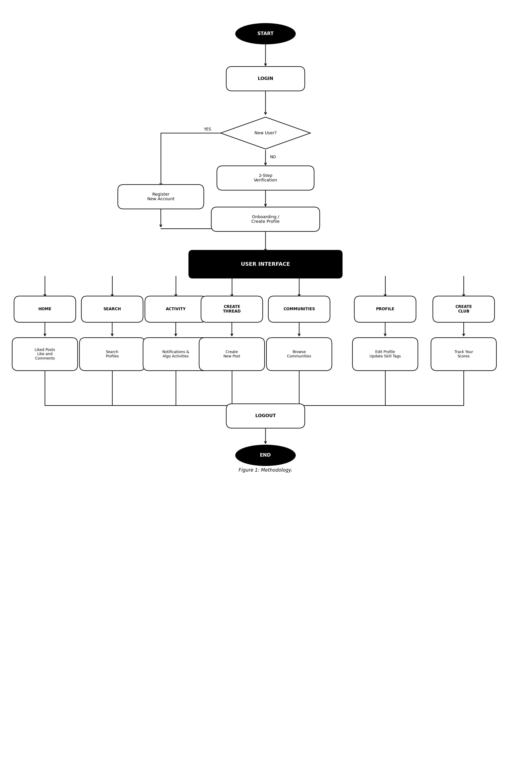
Figure 1: Methodology.
3.3. External Services
Third-party Authentication Services: We integrated Google OAuth2 so students can sign in without creating yet another password. It also speeds up onboarding since the basic profile info gets pulled automatically.
Communication Protocols:
WebSocket: Used for the chat module and live notifications. Socket.io made this easier to implement than raw WebSockets.
HTTP/HTTPS: All REST API calls, file uploads, and external service calls go over HTTPS. We enforced this strictly even in development.
Security Measures:
End-to-End Encryption: Chat messages are encrypted in transit. We didn’t want private student conversations being readable at the server level.
Access Controls: Admins, faculty, alumni, and students all have different access levels. A student can’t access the admin dashboard, and alumni can’t modify placement content.
3.4. Interaction Flow:
User Registration/Login: New users pick their role, fill in basic details, and either sign in with Google or set a password. Returning users just log in and land on their personalised feed.
Alumni–Student Networking: Students can browse alumni profiles filtered by company, branch, or graduation year and send a connection request. Alumni get a notification and can accept or decline.
Coding Practice: Students pick a problem, write code in the editor, and hit run. The Judge0 API executes the code and returns the verdict within seconds.
Project Showcase: Students fill in a project form with title, description, tech stack, team, and demo link. Other students and faculty can view, comment, or request collaboration.
Security Measures: All user data is protected through encrypted connections and strict role permissions. Sensitive actions require re-authentication.
Overall this flow is what we kept coming back to while building each module — what does the user actually do, step by step? That question shaped most of our design decisions, as shown in Figure 1.
4. EARLIER WORK
When we started building SkillSync, we first looked at what already exists and why it doesn’t quite work for students in a campus setting. LinkedIn is the obvious reference point — it’s great for connecting with professionals and alumni once you’re out of college, but inside the college it feels formal and a bit disconnected from the day-to-day academic experience. LeetCode and HackerRank are genuinely useful for coding prep, but they’re isolated tools — there’s no link between solving a problem there and your placement resources or alumni connections.
Community-Driven Platforms and Forums:
Reddit’s upvote-based Q&A model is probably the closest thing to what we wanted for the doubt-resolution forum. The idea that good answers rise to the top based on community votes, rather than just being the first reply, produces noticeably better discussion quality. We took that model and adapted it for an academic context — so faculty can mark verified answers, and the best responses show up first rather than the most recent (Smith et al., 2012).
Platform | Comparisons
LinkedIn | Professional networking, job listings, alumni connections.
GitHub | Version control, project collaboration and open-source sharing.
LeetCode | Competitive coding practice and interview preparation.
Stack Overflow | Community Q&A for programming and technical doubts.
Discord | Real-time messaging and community channels for groups.
Figure 2: Platform Comparisons.
Organization-Based Platforms and Privacy:
Facebook Groups and Reddit subreddits both show that people engage more when discussions are scoped to a specific community rather than being open to everyone on the internet. That insight shaped how we structured SkillSync’s communities — each one is either institution-specific or interest-specific, so conversations stay relevant and don’t get diluted. Unlike LinkedIn where anyone can see your activity, our platform lets students control what’s visible outside their institution (Shrestha et al., 2020).
User Interaction and Engagement:
GitHub taught us something important — a clean portfolio page does more for a student’s credibility than a list of achievements in a resume. We borrowed that philosophy for the project showcase module. Instead of just letting students write about their projects, we made it possible to link live demos, upload screenshots, and list teammates. Faculty can feature standout projects on the homepage, which gives students real motivation to do good work and document it properly (Maniou et al., 2021).
Security Measures in Campus Platforms:
Student data is sensitive — academic records, career goals, personal messages — and we took that seriously from the start. We looked at how platforms like GitHub handle repository access controls and used similar logic for our role-based permission system. Passwords are hashed with bcrypt, tokens expire after a set period, and all API endpoints require authentication. Private chats use encrypted transmission so even if someone intercepted the traffic, the messages wouldn’t be readable (Literat & Kligler-Vilenchik, 2021).
Future Trends in Campus Technology:
Looking at where things are heading, AI-based personalization seems like the most impactful near-term addition to SkillSync. Right now, alumni recommendations are based on filter criteria the student sets manually. With a basic recommendation model, the platform could suggest alumni based on the student’s academic performance, projects, and expressed interests. Similarly, predicting which students are placement-ready based on their coding activity and forum engagement could help faculty and placement cells be more proactive. We have left hooks in the architecture to support these additions later.
5. DISCUSSION
Building SkillSync was as much a learning experience as it was a development project. One thing we kept running into was the challenge of making multiple modules feel like one cohesive product rather than separate apps stitched together. The navigation, notification system, and shared user context had to work consistently across all eight modules — and getting that right took several rounds of refactoring.
The coding module was where we got the most positive feedback during testing. Students liked being able to practice problems without switching tabs, and several mentioned they appreciated seeing their submission history tied to their profile. The alumni networking module, on the other hand, needs more alumni participation to truly be useful — which is more of a user adoption challenge than a technical one. The Judge0 API occasionally had latency spikes which we noticed during peak hours, and we are looking at caching strategies to handle that better in future versions.
6. CONTRIBUTION
The main thing SkillSync Campus contributes is the idea that a campus platform should not be fragmented. To our knowledge, no existing product brings alumni networking, coding practice with a live compiler, placement content management, a Q&A forum, real-time chat, and project showcase together in a campus-specific context. Each of these exists in isolation, but combining them under one authentication layer with shared user context creates something genuinely different.
On the technical side, embedding Judge0 within a campus networking platform is something we haven’t seen done before. It means a student can go from reading a placement preparation tip, to practicing the relevant coding problem, to asking a doubt in the forum, to checking if an alumnus at that company is available for a chat — all without leaving the app. That kind of connected experience is what we wanted to build, and we think it genuinely changes how placement preparation feels for students.
7. CONCLUSION
SkillSync Campus came out of a real frustration we had as students — the tools available to us were good individually but disconnected from each other and from the campus context. What we built tries to fix that. By bringing alumni networking, coding practice, placement prep, discussion forums, project showcase, and real-time chat into one place, we wanted to reduce the friction students face every day when trying to grow professionally and academically.
The tech stack we chose held up well throughout development. Node.js and Express handled concurrent requests without issues, the dual-database approach using PostgreSQL and MongoDB made sense for the different types of data we were storing, and Judge0 delivered reliable code execution without us having to build that infrastructure ourselves. Socket.io’s real-time features worked smoothly once we sorted out some initial connection handling bugs.
There is still a lot we want to improve. The recommendation engine for alumni matching is something we plan to work on next. We also want to add a leaderboard for coding practice and explore integration with the college’s ERP system for automatic profile verification. But as a foundation, we are fairly happy with where SkillSync Campus stands today and what it can already do for students.
8. ACKNOWLEDGEMENT
Rishabh Rawat took the lead on backend architecture and kept the whole project on track. His work on the Node.js and Express.js services, and the way he set up the database schemas in PostgreSQL, made it much easier for the rest of us to build on top of without stepping on each other. His habit of writing clean, well-commented code was something we all learnt from.
Sumiran Sharma handled most of the frontend and made the app actually pleasant to use. The React components he built for the web version and the Flutter screens for mobile were both clean and consistent. He had a good eye for where the UI felt off and would fix things proactively, which saved a lot of back-and-forth during testing.
Abhishek Karan worked across both frontend and backend and was particularly focused on making sure the security side was solid. Setting up JWT authentication, role-based access, and the encrypted chat were largely his contributions. He was also the one who caught a few tricky bugs during integration that could have caused real problems later.
We want to sincerely thank Mr. Ashish Patel, our mentor, for guiding us through the tougher decisions in this project. Whether it was choosing between database options or figuring out how to structure the API, his advice was always practical and grounded. We also thank the faculty and staff at Dronacharya Group of Institutions, Greater Noida, for supporting us throughout.
References.
He, W., Zha, S., & Li, L. (2013). Social media competitive analysis and text mining: A case study in the pizza industry. International Journal of Information Management, 33(3), 464-472. https://doi.org/10.1016/j.ijinfomgt.2013.01.001
Jhaver, S., Bruckman, A., & Gilbert, E. (2019). Does transparency in moderation really matter? User behavior after content removal explanations on Reddit. Proceedings of the ACM on Human-Computer Interaction, 3(CSCW), 1-27. https://doi.org/10.1145/3359252
Kumar, R., & Sharma, S. (2022). Design and implementation of a campus social network for enhancing student engagement. IEEE Access, 10, 22010–22025. https://doi.org/10.1109/ACCESS.2022.3152301
Literat, I., & Kligler-Vilenchik, N. (2021). How popular culture prompts youth collective political expression on social media. Social Media + Society, 7(2). https://doi.org/10.1177/20563051211008821
Maniou, T. A., & Bantimaroudis, P. (2021). Hybrid salience: Examining the role of traditional and digital media. Journalism, 22(4), 1127-1144. https://doi.org/10.1177/1464884918796587
Prinster, G. H., Smith, C. E., Tan, C., & Keegan, B. C. (2024). Community archetypes: An empirical framework for guiding research methodologies. Proceedings of the ACM on Human-Computer Interaction, 8(CSCW1), 1-33. https://doi.org/10.1145/3637310
Shrestha, P., Sathanur, A., Maharjan, S., Saldanha, E., Arendt, D., & Volkova, S. (2020). Multiple social platforms reveal actionable signals for software vulnerability awareness: A study of GitHub, Twitter and Reddit. Plos One, 15(3), e0230250. https://doi.org/10.1371/journal.pone.0230250
Smith, A. N., Fischer, E., & Yongjian, C. (2012). How does brand-related user-generated content differ across YouTube, Facebook, and Twitter? Journal of Interactive Marketing, 26(2), 102-113. https://doi.org/10.1016/j.intmar.2012.01.002
Toraman, C., Sahinuc, F., Yilmaz, E. H., & Akkaya, I. B. (2022). Understanding social engagements: A comparative analysis of user and text features in Twitter. Social Network Analysis and Mining, 12(1), 47. https://doi.org/10.1007/s13278-022-00872-1
Verma, A., Harper, M., Assi, S., Al-Hamid, A., Yousif, M. G., & Mustafina, J. (2022). Suicide ideation detection: A comparative study of sequential and transformer hybrid algorithms. In International Conference on Data Science and Emerging Technologies (pp. 373-387). Springer Nature Singapore. https://doi.org/10.1007/978-981-99-0741-0_27
Patel, A., Verma, N., & Singh, K. (2023). Unified academic platforms: Challenges and opportunities in campus ecosystems. In Proc. IEEE International Conference on Educational Technology, New Delhi, India, pp. 112–117.
Nguyen, T., Tran, P., & Hoang, L. (2022). Integrated learning environments and student academic performance: Evidence from Southeast Asian universities. Computers & Education, 178, 104-119. https://doi.org/10.1016/j.compedu.2021.104382
Kassim, H., Ahmad, R., & Yusof, M. (2022). The role of mentorship in undergraduate placement outcomes: A systematic review. International Journal of Educational Technology, 15(2), 45–58.
Singha, S. (2024). Exploring the role of social media in enhancing K-12 economics education. In Cases on Economics Education and Tools for Educators (pp. 160–182). IGI Global. https://doi.org/10.4018/978-1-6684-7583-6.ch007

